# Lesson 6 – From Designer to Code

* Class_Globals
* Variables and Subs
* Passing Values to Code
* Events
* Attributes

What students should know

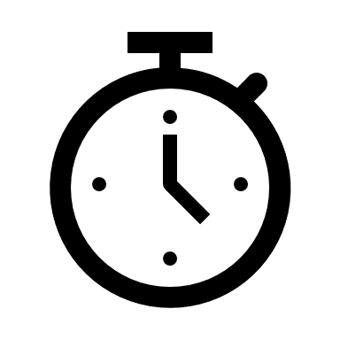**2h**

Designing the app's appearance in Designer is the first step in the manufacturing stages. Often new developers turn to it to redesign, correct, or add individual information.

When the screen is ready the developer goes to the next stage of programming the functions. That is, creating the elements included in the design to gain functionality. In other words, text boxes can record data, buttons can activate functions, lists can display data, etc.

## Class_Globals

When the B4XMainPage tab is clicked a code page is revealed. At the beginning of the code there is a set of variable declarations between Sub Class_Globals and End Sub.

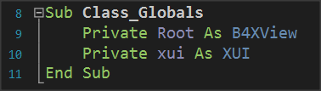As has already been said in the 3rd Lesson Sub is a set of code that performs a specific operation. The intent of the Class_Globals is to collect the declarations of variables that we want to be known throughout the code within the B4XMainPage module, i.e. in each subprogram.

Picture 1 Sub Class_Globals

In addition, if a variable statement starts with the public it will be available from within other program modules.

## A deeper look at the use of variables.

In the following code you see three subprograms

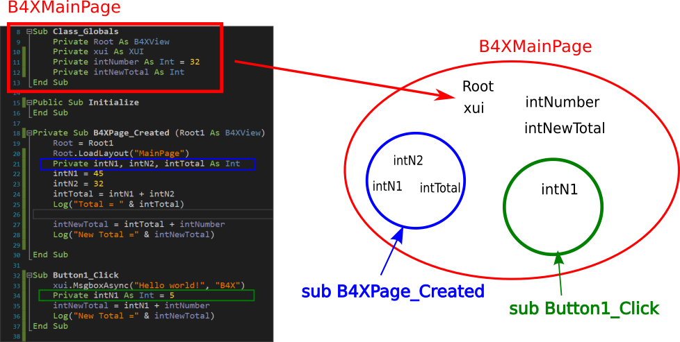

Picture 2 Variables and Range

The intNumber, intNewTotal, Root, and xui variables declared within Class_Globals "live" within module B4 XMainPage.

In contrast, variables intN1, intN2, intTotal 'live' within the sub-program B4XPage_Created and for this reason No another subprogram may use them. At the same time, the variable **intN1** lives in the **Button1_Click** **is not the same** the one in **B4XPage_Created**, each occupies its own memory space, and both can have the same name. This is referred to as the scope of the variables meaning how widely within a module or the whole program a variable is accessible, or, to where access to a variable is restricted.

**Teachers tip**

The use and range of variables is something that confuses new developers. Depending on your class, it is recommended to make examples of familiarity in their use.



## Passing Values to Code

The screen you have already prepared contains objects that you must declare as variables in Class _ Globals to use in the program.

In the example, in the previous lesson, some of the objects on the screen do not have to be included in the code.

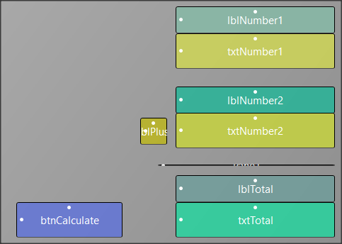

Picture 3 Example 1 Designer View

So, all "labels" items in this application do not have to be managed by code. While button and textFields which will have programmable characteristics, must be added into the code editor in order to program their functions.

There are two ways to insert your objects into the code. The first is easily done through the designer with the following functions:

From the Tools menu select Generate Members

In Screen Generate Members just click on objects

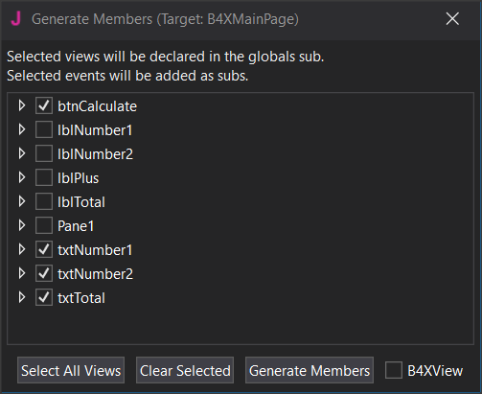

Picture 4 Generate Members

* btnCalculate
* txtNumber1
* txtNumber2
* txtTotal

and then click Generate Members.

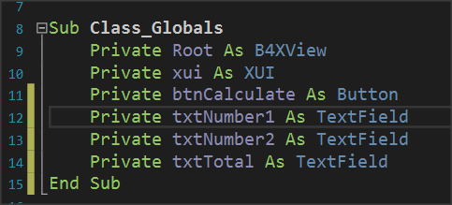

Picture 5 Class_Globals

Your code in the Class_Globals subprogram will be updated automatically with the variables.

**Remember**

Each object we import is of a certain type as well as the types of variables.

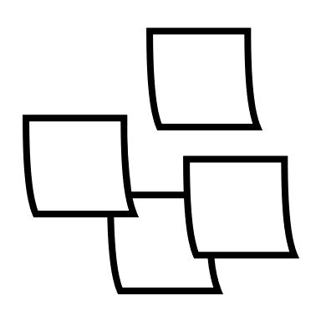

The second input solution is to type the declarations for the variables yourself, paying attention so that the names of the objects in the designer screen match.

## Events

After you have declared the variables of the objects, the final stage is to write the program code for the functions of the form.

This will depend on what features and functions you have decided your app will have. In the example with the two numbers there is a button called Calculate which performs the addition when clicked and triggers the presentation of the result on your screen.

The operation is triggered by a process called an "**Event**. The programmer must detect the event of pressing the Calculate key and when this is done then do the relevant calculations and display the result.

**Remember**

There are hundreds of different events happening in one application; the developer determines how the program will react to each of them.



The detection of the event is easy and you just need to create a new subprogram that has the name of the event. This can be done at the same time as the declaration of the variables of our objects through the Designer.

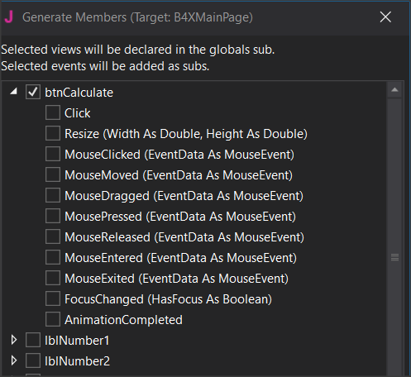

Picture 6 Setting Event

To see the Events associated with a program object open its list btnCalculate and several Events will be available to choose from. Just click on "Click” and "Generate Members”.

Your code in the Class_Globals subprogram will be updated automatically with the variable declarations. Within it you will write the program code to complete.

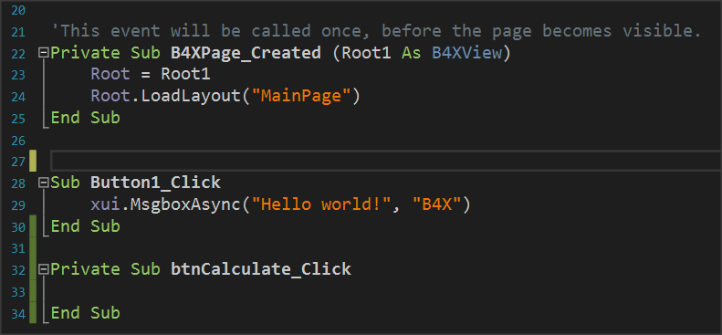

Picture 7 The Click Event

## 

## Writing code in Event

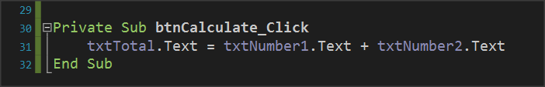All the functions associated with an object are performed within the Event subprogram.

Picture 8 Calculating textFields

Essentially both are achieved with a single command. This is the command of Picture 8 Calculating textFields follows:

*The content of textField txtTotal* is equal to the contents of *txtNumer1* and *txtNumber2.*

### Properties

Each object you insert into your code has a number of different properties. For example properties can be the color, size, location content as they have been described and in the previous lesson. These properties can provide information or change display characteristics. For example, the property txtNumber1.text provides information on the content of the object txtNumber1 or can set a value as content depending on how you use it. This information is string type.

**Remember**

You can do operations with string contents when they describe numbers.



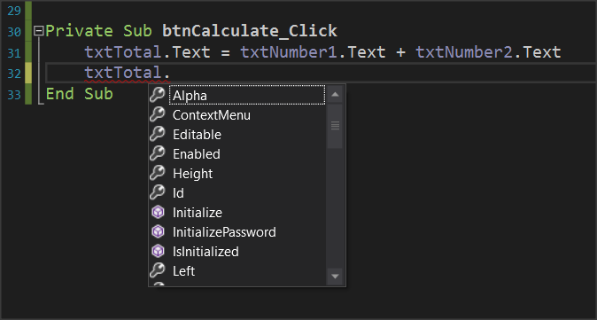

Picture 9 Object Properties

Let us now assume that we want to create a new function in the example where another button clears the form to write new numbers. The functions you will perform are as follows:

* Open Designer and add a new button named e.g. btnClear.
* Set it as a variable in Class_Global.
* Enter the event btnClear_Click.
* Set the text properties of txtNumber1, txtNumber2, txtTotal to "".

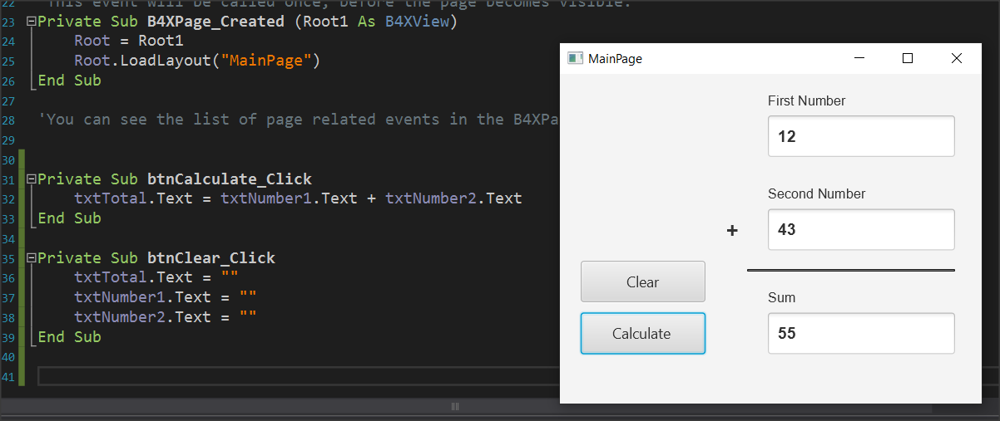

Picture 10 Clear Button and Code

When you press clear, the form will clear.

## Exercises

1. Extend the example to perform the four operations: Add, subtract, multiply, and divide at the click of an appropriate button. Add the appropriate objects to the designer and then complete the code.

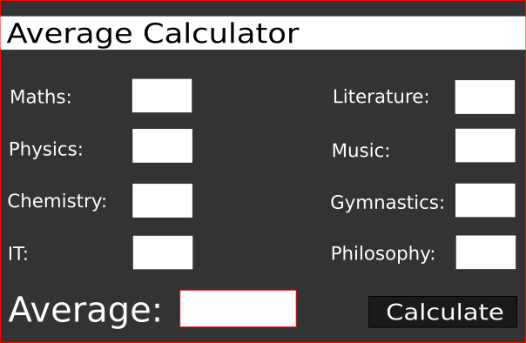2. In exercise 2 of the previous course continue lesson and complete the application by activating its functions.

Take care that the scores for each subject must be between 0-100. If not, you should show an error message.